T2 Ratio Plug-in
Antoine Rosset, 2004

Pre and Post contrast T2 ratio

- Open two series:
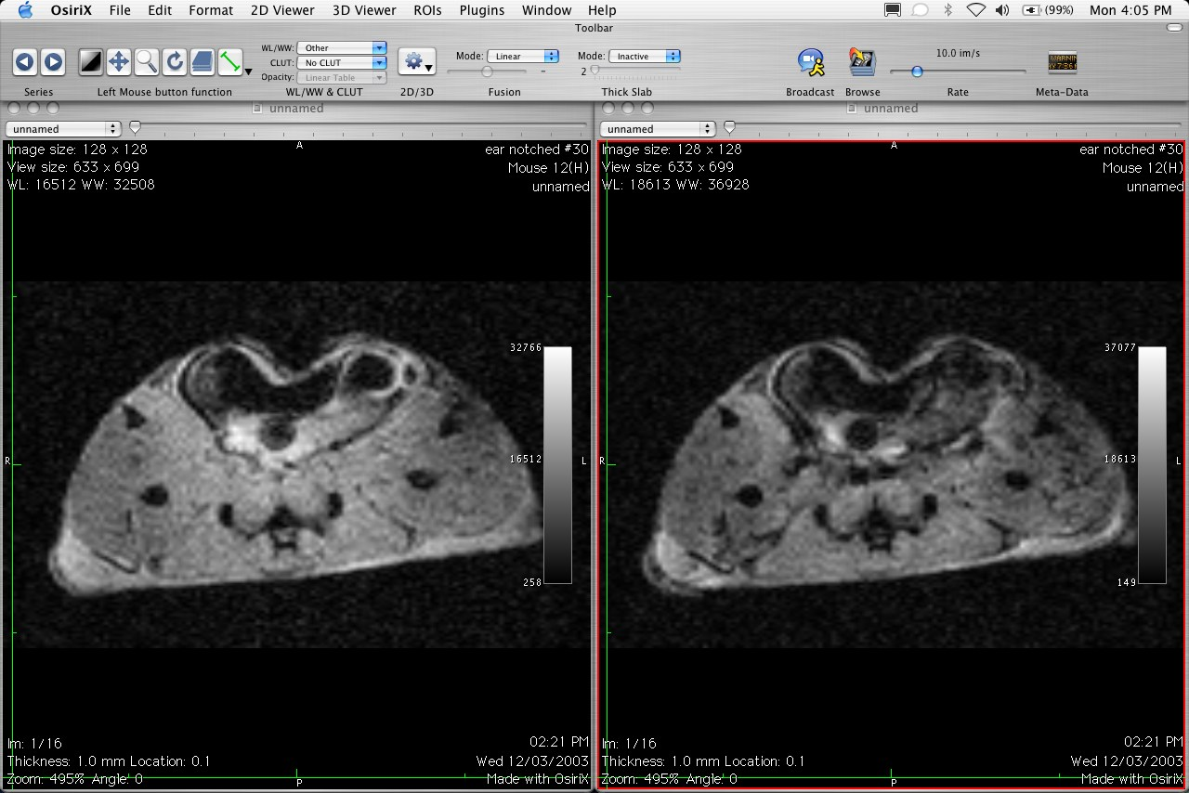
Left is PRE-contrast GRE Right is POST-contrast GRE

- Drag & Drop POST-contrast on PRE-contrast series. Select the T2 Ratio plugin.
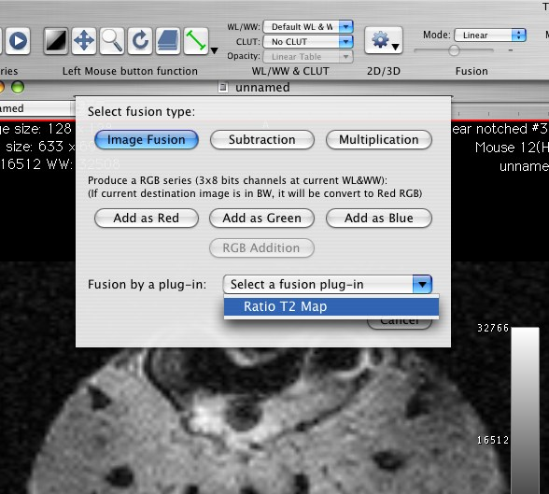

- Adjust parameters in T2 Ratio window. You can limit the computation to only selected ROIs of the PRE-contrast series.
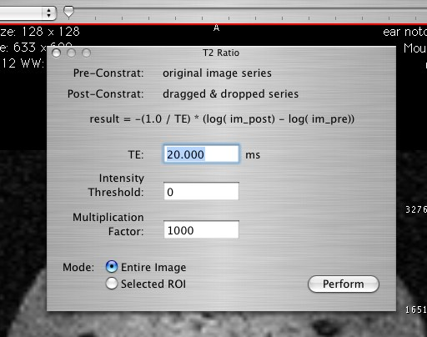
Click Perform to produce the T2 Ratio series.

- Drag & Drop this new series on your PRE or POST contrast series to produce a series with image fusion. Adjust the CLUT, window levels and image fusion percentage.
